**SEQUENCE in SQL Server 2011**

By [Dinesh Asanka](http://www.sql-server-performance.com/author/dineshasanka/)

SQL Server 2011 (or *Denali*) has now arrived CTP. In this article I will look at a core new feature of SQL Server 2011 which is SEQUENCE. Well, if you are familiar with Oracle, you will already know all about this feature since it has been standard on Oracle more than 10 years I guess.

**What is Sequence in SQL Server ?**

In simple terms, it is a new database object and a substitute for the Identity of columns.

Using the identity attribute for a column, you can easily generate auto-incrementing numbers (which as often used as a primary key). With Sequence, it will be a different object which you can attach to a table column while inserting. **Unlike identity, the next number for the column value will be retrieved from memory rather than from the disk – this makes Sequence significantly faster than Identity**. We will see this in coming examples.

**Creating a Sequence in SQL Server**

To use Sequence first SQL Server Management Studio (SSMS) and expand the Object explorer, under programmability you will see the sequence node.

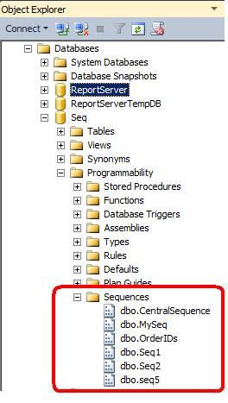

If you right click the sequence and select new, you will be taken to the below screen which has all the attributes for the sequence.

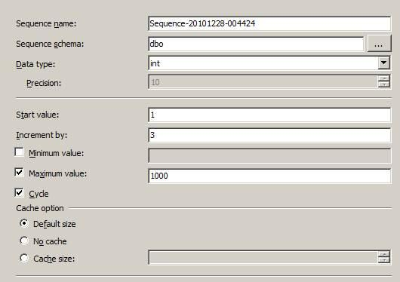

Since Sequence is a database object, it needs to be assigned to a schema. It has a data type which can be int, bigint, tinyint, smallint,numeric or decimal. The start value and increment as similar as to the values you will be familiar with using Identity.

The Minimum and maximum are boundaries for the sequence. When the cycle option is set you have the ability to re-use sequence numbers.

Similarly, Sequences can be created using T-SQL as follows.

**IF EXISTS (SELECT * FROM sys.sequences WHERE name = N’EmployeeSeq’)  
                DROP SEQUENCE EmployeeSeq;  
GO**

**CREATE SEQUENCE EmployeeSeq AS tinyint  
                START WITH 0  
                INCREMENT BY 5;  
GO**

Now let us see how we can integrate this with an Insert statement.

First we will create a table to incorporate the sequence we created.

**CREATE TABLE Employee   
(ID tinyint,  Name varchar(150) )**

Then we will insert:

**INSERT INTO Employee  
(ID,Name)  
VALUES   
(NEXT VALUE FOR EmployeeSeq, ‘Dinesh’)  
INSERT INTO Employee  
(ID,Name)**

**VALUES   
(NEXT VALUE FOR EmployeeSeq, ‘Asanka’)**

Note that you are now using the EmployeeSeq sequence object for the insert.

**New Features**

* [Sequences](http://www.sql-server-performance.com/articles/dev/sequence_sql_server_2011_p1.aspx)
* [Extended FILESTREAM](http://msdn.microsoft.com/en-us/library/bb933993%28v=sql.110%29.aspx) (thanks to [Eric Humphrey](http://dba.stackexchange.com/questions/736/is-it-better-to-store-images-in-a-blob-or-just-the-url/741#741))
* [OFFSET & FETCH (ORDER BY Clause)](http://msdn.microsoft.com/en-us/library/ms188385%28v=SQL.110%29.aspx)
* [Memory Manager Changes](http://sqlblog.com/blogs/sqlos_team/archive/2011/01/04/sql-server-memory-manager-changes-in-denali.aspx)
* [LAG](http://msdn.microsoft.com/en-us/library/hh231256%28v=SQL.110%29.aspx)(..) and [LEAD](http://msdn.microsoft.com/en-us/library/hh213125%28v=SQL.110%29.aspx)(..) .. OVER (Partition By..Order By) clause (thanks to [gbn](http://dba.stackexchange.com/questions/401/what-is-sql-server-denali-whats-new/7035#7035))

| Category | Statements |
| --- | --- |
| Date and time statements | [SET DATEFIRST](http://msdn.microsoft.com/en-us/library/ms181598(v=SQL.110).aspx)  [SET DATEFORMAT](http://msdn.microsoft.com/en-us/library/ms189491(v=SQL.110).aspx) |
| Locking statements | [SET DEADLOCK_PRIORITY](http://msdn.microsoft.com/en-us/library/ms186736(v=SQL.110).aspx)  [SET LOCK_TIMEOUT](http://msdn.microsoft.com/en-us/library/ms189470(v=SQL.110).aspx) |
| Miscellaneous statements | [SET CONCAT_NULL_YIELDS_NULL](http://msdn.microsoft.com/en-us/library/ms176056(v=SQL.110).aspx)  [SET CURSOR_CLOSE_ON_COMMIT](http://msdn.microsoft.com/en-us/library/ms184746(v=SQL.110).aspx)  [SET FIPS_FLAGGER](http://msdn.microsoft.com/en-us/library/ms189781(v=SQL.110).aspx)  [SET IDENTITY_INSERT](http://msdn.microsoft.com/en-us/library/ms188059(v=SQL.110).aspx)  [SET LANGUAGE](http://msdn.microsoft.com/en-us/library/ms174398(v=SQL.110).aspx)  [SET OFFSETS](http://msdn.microsoft.com/en-us/library/ms188731(v=SQL.110).aspx)  [SET QUOTED_IDENTIFIER](http://msdn.microsoft.com/en-us/library/ms174393(v=SQL.110).aspx) |
| Query Execution Statements | [SET ARITHABORT](http://msdn.microsoft.com/en-us/library/ms190306(v=SQL.110).aspx)  [SET ARITHIGNORE](http://msdn.microsoft.com/en-us/library/ms184341(v=SQL.110).aspx)  [SET FMTONLY](http://msdn.microsoft.com/en-us/library/ms173839(v=SQL.110).aspx)  Note**Note**  This feature will be removed in a future version of Microsoft SQL Server. Avoid using this feature in new development work, and plan to modify applications that currently use this feature.  [SET NOCOUNT](http://msdn.microsoft.com/en-us/library/ms189837(v=SQL.110).aspx)  [SET NOEXEC](http://msdn.microsoft.com/en-us/library/ms188394(v=SQL.110).aspx)  [SET NUMERIC_ROUNDABORT](http://msdn.microsoft.com/en-us/library/ms188791(v=SQL.110).aspx)  [SET PARSEONLY](http://msdn.microsoft.com/en-us/library/ms178629(v=SQL.110).aspx)  [SET QUERY_GOVERNOR_COST_LIMIT](http://msdn.microsoft.com/en-us/library/ms176100(v=SQL.110).aspx)  [SET ROWCOUNT](http://msdn.microsoft.com/en-us/library/ms188774(v=SQL.110).aspx)  [SET TEXTSIZE](http://msdn.microsoft.com/en-us/library/ms186238(v=SQL.110).aspx) |
| ISO Settings statements | [SET ANSI_DEFAULTS](http://msdn.microsoft.com/en-us/library/ms188340(v=SQL.110).aspx)  [SET ANSI_NULL_DFLT_OFF](http://msdn.microsoft.com/en-us/library/ms187356(v=SQL.110).aspx)  [SET ANSI_NULL_DFLT_ON](http://msdn.microsoft.com/en-us/library/ms187375(v=SQL.110).aspx)  [SET ANSI_NULLS](http://msdn.microsoft.com/en-us/library/ms188048(v=SQL.110).aspx)  [SET ANSI_PADDING](http://msdn.microsoft.com/en-us/library/ms187403(v=SQL.110).aspx)  [SET ANSI_WARNINGS](http://msdn.microsoft.com/en-us/library/ms190368(v=SQL.110).aspx) |
| Statistics statements | [SET FORCEPLAN](http://msdn.microsoft.com/en-us/library/ms188344(v=SQL.110).aspx)  [SET SHOWPLAN_ALL](http://msdn.microsoft.com/en-us/library/ms187735(v=SQL.110).aspx)  [SET SHOWPLAN_TEXT](http://msdn.microsoft.com/en-us/library/ms176058(v=SQL.110).aspx)  [SET SHOWPLAN_XML](http://msdn.microsoft.com/en-us/library/ms187757(v=SQL.110).aspx)  [SET STATISTICS IO](http://msdn.microsoft.com/en-us/library/ms184361(v=SQL.110).aspx)  [SET STATISTICS XML](http://msdn.microsoft.com/en-us/library/ms176107(v=SQL.110).aspx)  [SET STATISTICS PROFILE](http://msdn.microsoft.com/en-us/library/ms188752(v=SQL.110).aspx)  [SET STATISTICS TIME](http://msdn.microsoft.com/en-us/library/ms190287(v=SQL.110).aspx) |
| Transactions statements | [SET IMPLICIT_TRANSACTIONS](http://msdn.microsoft.com/en-us/library/ms187807(v=SQL.110).aspx)  [SET REMOTE_PROC_TRANSACTIONS](http://msdn.microsoft.com/en-us/library/ms178549(v=SQL.110).aspx)  [SET TRANSACTION ISOLATION LEVEL](http://msdn.microsoft.com/en-us/library/ms173763(v=SQL.110).aspx)  [SET XACT_ABORT](http://msdn.microsoft.com/en-us/library/ms188792(v=SQL.110).aspx) |

Total No. is 40